# Stock price evaluation

**Introduction**

*“If you take the modern world where people are trying to teach you to come in and trade actively in stocks, well I regard that as roughly equivalent to trying to induce a bunch of young people to start off on heroin,”* Charlie Munger, a renowned investor and long-term business partner of Warren Buffet, commented in an interview [1]. Instead, he suggested everyday investors to work with established index funds to make investments[2]. However, the authors of this stock price evaluation program take the view that every-day investors may also create their own independent stock price programs to critically reflect their investments. Exactly such a program will be presented now.

The main idea of the program is to give the user a proposal of whether he should sell or buy a stock of a certain industry. To do so, the program will retrieve different data of four different stocks via “Yahoo finance!” and compare them in a typical multiple comparison analysis, used in the finance industry.

**To do list for the user BEFORE she/he can run the code**

At first, the user must visit this website (<https://thonny.org/> ; Retrieved December 17, 2019) and download “Thonny” (version 3.2.4), which can be found on the upper right.

Then, after having installed the Thonny program, the user must copy the code from the file “Stock price evaluation program (code)” which can be found here on the “Stock-price-evaluation-program” repository on Github (<https://github.com/Fire90s/Stock-price-evaluation-program.git> ).

After having copied the code from the “stock price evaluation program (code)”, the user can insert the code in the downloaded Thonny program.

Before the user is able to run the program, she/he is required to download some packages. Therefore, the user may click on “Tools” at the top bar and choose “Manage packages…” (see figure 1). The packages she/he has to install are the following: DateTime, matplotlib, numpy, pandas, pandas-datareader, yahoofinancials, yahoo-finance.

Afterwards, the user can press the green “run” button at the top left (see figure 2), save the document and run the code. For further information and explanations regarding the input consult chapters “User Input and Output” and “Example”.

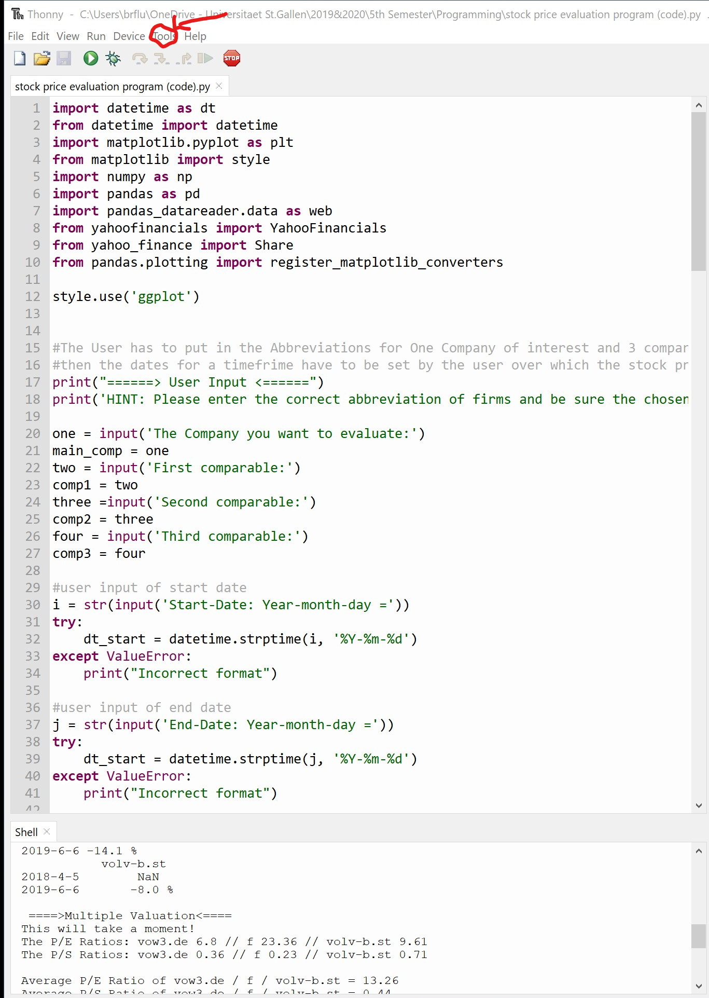

Figure 1: The "Tools" button at the top left circled in red

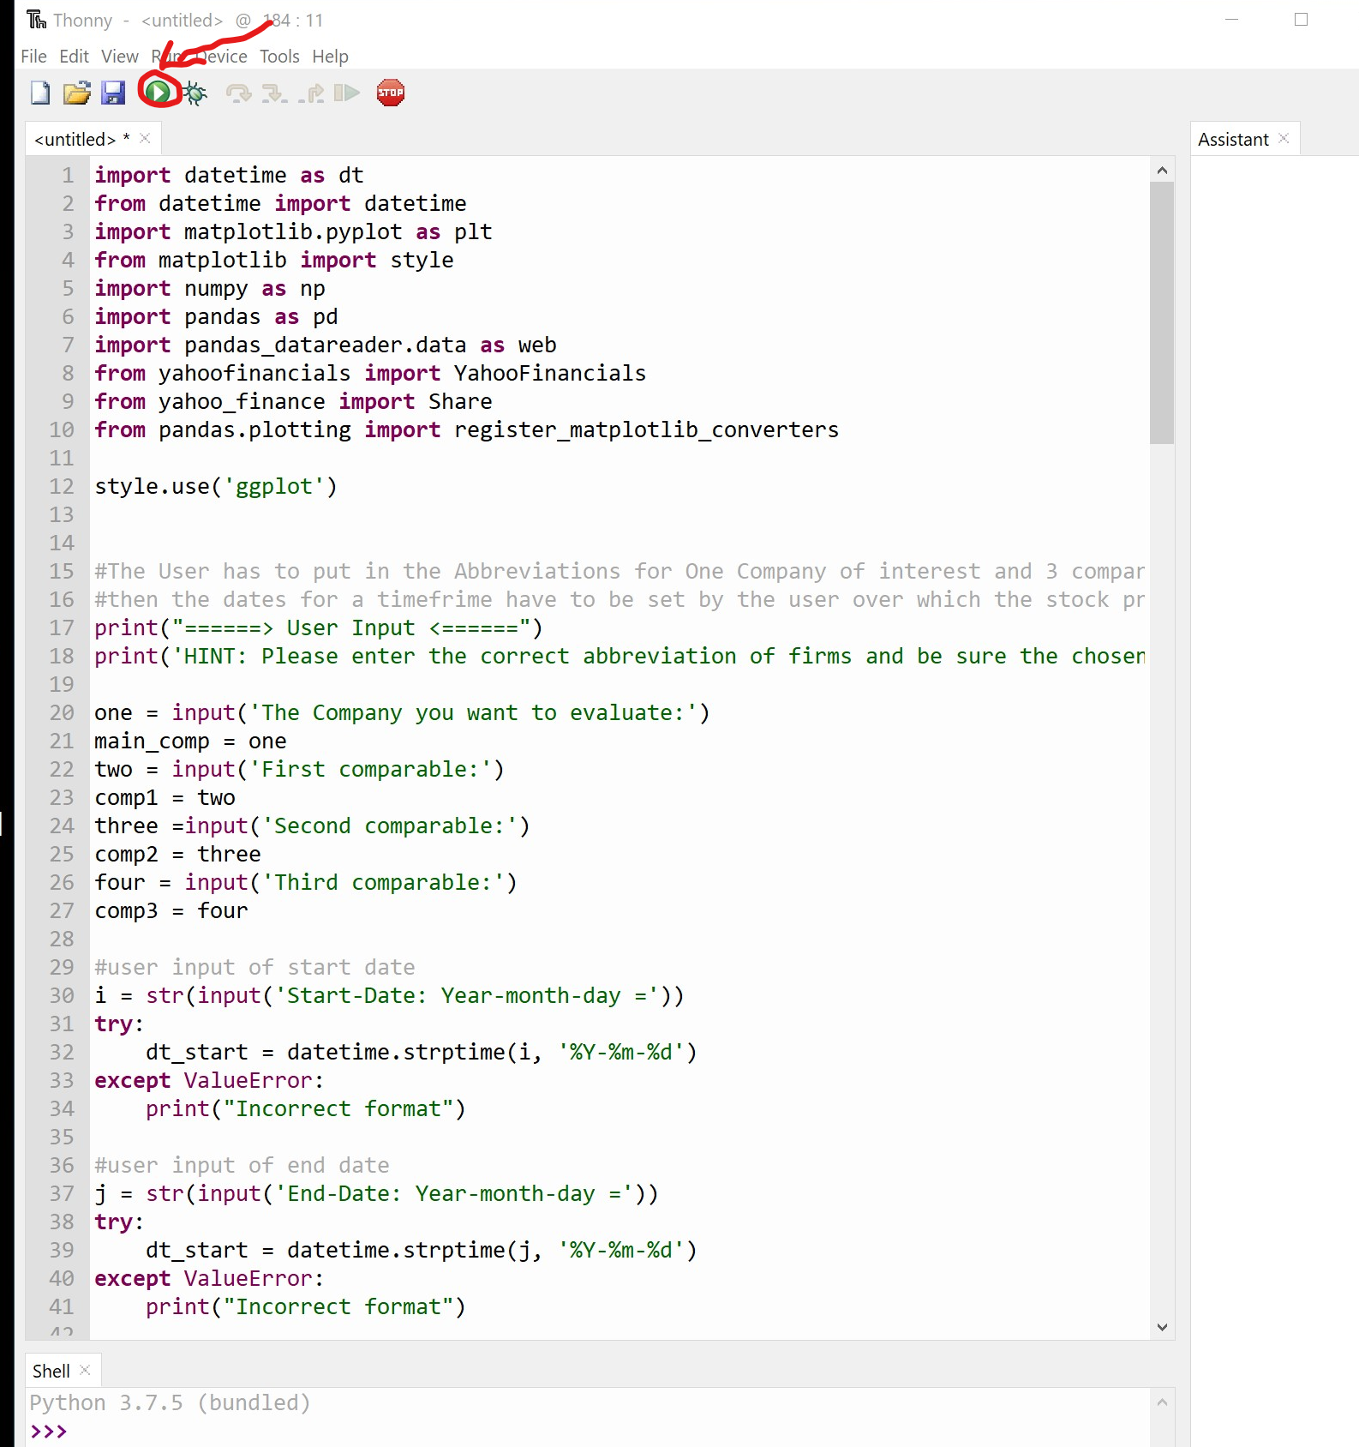

Figure 2: The green "run" button circled in red

**User Input and Output**

*User Input*

In a first step, the user determines the company he wants to evaluate (“main_comp”). Then, he writes the abbreviations of three comparable companies from the same industry into the input fields. Lastly, he gives the program a timeframe over which the stock data shall be retrieved.

*Output*

The closing values for the specific dates entered by the user will be shown in the shell. Using these values, the program computes the percentage change of the closing values over the entered time frame for all four stocks. These developments are also portrayed in a pandas plot.

In a next step, the program retrieves the P/E and P/S ratio for the main company and the three comparables. Afterwards, it calculates the average of the P/E and P/S ratios of the three comparable firms. These industry averages are then multiplied with the EPS and Sales number (retrieved by the program from “Yahoo finance!”) of the main company of interest. This will result in two share price predictions for this company: The P/E price prediction and the P/S price prediction. Out of the two price predictions the program calculates the average and compares this to the main company’s current share price. If the predicted price is above the current price of the stock, the program will issue a BUY recommendation.

**Example**

To explain the whole program, the authors use an example to illustrate:

Let’s assume that the user is unsure whether he should sell/buy a Volkswagen stock. Therefore, he/she makes use of this stock evaluation program. At first, he/she names the abbreviation of Volkswagen (vow3.de) as “The company you want to evaluate” and then he/she inserts three other abbreviations of “comparable” companies from the same industry such as BMW (bmw.de), Ford (f) and Volvo (volv-b.st). After having done so, the program will use the three “comparables” (e.g. BMW, Ford and Volvo) as a benchmark for later comparisons. Afterwards the user must define the time frame within which the data shall be drawn. Afterwards, the program will search for the stocks’ closing values. Then, the essential numbers (closing values, closing values percentage change, P/E ratio and EPS) for Volkswagen, the user’s primary interest, are printed. Important to note is that the user can only search for companies which have already existed within the stated time frame and actually have P/E (Current share price relative to per-share earnings (EPS)) and P/S (price-to-sales) ratios. To fact check this, the user can simply visit “Yahoo! finance” (<https://finance.yahoo.com/>) and verify whether the respective firms have such values. Moving on, the closing values and the closing value percentage change of the other three automotive firms are printed. Following, P/E and P/S ratios of the comparable firms are retrieved and the average P/E and P/S ratio for automotive industry as well as Volkswagen’s share prices based on P/E and P/S are printed. From the industry averages share price predictions are calculated by multiplying average P/E with VWs EPS and average P/S with VWs Sales per Share. Lastly, the average price expectation of the Volkswagen share is compared to the current Volkswagen share price and if the latter is lower than the former, the user will be recommended to “BUY” the Volkswagen share. This suggestion is based on the logic that the Volkswagen share might be underpriced compared to its industry peers. Subsequently, a graph with the “Closing Share Price Values” development within the chosen time frame pops up which allows the user to analyze the past trends of the four car manufacturers’ share prices.

1. <https://www.cnbc.com/2019/02/14/charlie-munger-teaching-young-people-to-trade-stocks-is-like-to-starting-them-on-heroin.html> (Retrieved December 4, 2019)
2. See reference 1.